Frequencies

[DataSet1]

Statistics
 |  | PK01 | PK02 | PK03 | PK04 | PK05 | PK06
N | Valid | 113 | 113 | 113 | 113 | 113 | 113
N | Missing | 0 | 0 | 0 | 0 | 0 | 0
Mean |  | 3,44 | 3,30 | 3,35 | 3,23 | 3,25 | 3,25
Median |  | 3,00 | 3,00 | 3,00 | 3,00 | 3,00 | 3,00
Mode |  | 3 | 3 | 3 | 3 | 3 | 3
Std, Deviation |  | ,516 | ,639 | ,533 | ,535 | ,492 | ,473
Variance |  | ,267 | ,409 | ,284 | ,286 | ,242 | ,224
Minimum |  | 2 | 1 | 2 | 2 | 1 | 2
Maximum |  | 4 | 4 | 4 | 4 | 4 | 4
Sum |  | 389 | 373 | 379 | 365 | 367 | 367

Frequency Table

PK01
 |  | Frequency | Percent | Valid Percent | Cumulative Percent
Valid | 2 | 1 | ,9 | ,9 | ,9
Valid | 3 | 61 | 54,0 | 54,0 | 54,9
Valid | 4 | 51 | 45,1 | 45,1 | 100,0
Valid | Total | 113 | 100,0 | 100,0

PK02
 |  | Frequency | Percent | Valid Percent | Cumulative Percent
Valid | 1 | 3 | 2,7 | 2,7 | 2,7
Valid | 2 | 2 | 1,8 | 1,8 | 4,4
Valid | 3 | 66 | 58,4 | 58,4 | 62,8
Valid | 4 | 42 | 37,2 | 37,2 | 100,0
Valid | Total | 113 | 100,0 | 100,0

PK03
 |  | Frequency | Percent | Valid Percent | Cumulative Percent
Valid | 2 | 3 | 2,7 | 2,7 | 2,7
Valid | 3 | 67 | 59,3 | 59,3 | 61,9
Valid | 4 | 43 | 38,1 | 38,1 | 100,0
Valid | Total | 113 | 100,0 | 100,0

PK04
 |  | Frequency | Percent | Valid Percent | Cumulative Percent
Valid | 2 | 6 | 5,3 | 5,3 | 5,3
Valid | 3 | 75 | 66,4 | 66,4 | 71,7
Valid | 4 | 32 | 28,3 | 28,3 | 100,0
Valid | Total | 113 | 100,0 | 100,0

PK05
 |  | Frequency | Percent | Valid Percent | Cumulative Percent
Valid | 1 | 1 | ,9 | ,9 | ,9
Valid | 3 | 82 | 72,6 | 72,6 | 73,5
Valid | 4 | 30 | 26,5 | 26,5 | 100,0
Valid | Total | 113 | 100,0 | 100,0

PK06
 |  | Frequency | Percent | Valid Percent | Cumulative Percent
Valid | 2 | 2 | 1,8 | 1,8 | 1,8
Valid | 3 | 81 | 71,7 | 71,7 | 73,5
Valid | 4 | 30 | 26,5 | 26,5 | 100,0
Valid | Total | 113 | 100,0 | 100,0

Frequencies

Statistics
 |  | LK01 | LK02 | LK03 | LK04 | LK05 | LK06
N | Valid | 113 | 113 | 113 | 113 | 113 | 113
N | Missing | 0 | 0 | 0 | 0 | 0 | 0
Mean |  | 3,28 | 3,22 | 3,41 | 3,52 | 3,42 | 3,35
Median |  | 3,00 | 3,00 | 3,00 | 4,00 | 3,00 | 3,00
Mode |  | 3 | 3 | 3 | 4 | 3 | 3
Std, Deviation |  | ,619 | ,637 | ,511 | ,502 | ,564 | ,478
Variance |  | ,383 | ,406 | ,261 | ,252 | ,318 | ,228
Minimum |  | 2 | 1 | 2 | 3 | 2 | 3
Maximum |  | 4 | 4 | 4 | 4 | 4 | 4
Sum |  | 371 | 364 | 385 | 398 | 387 | 378

Frequency Table

LK01
 |  | Frequency | Percent | Valid Percent | Cumulative Percent
Valid | 2 | 10 | 8,8 | 8,8 | 8,8
Valid | 3 | 61 | 54,0 | 54,0 | 62,8
Valid | 4 | 42 | 37,2 | 37,2 | 100,0
Valid | Total | 113 | 100,0 | 100,0

LK02
 |  | Frequency | Percent | Valid Percent | Cumulative Percent
Valid | 1 | 4 | 3,5 | 3,5 | 3,5
Valid | 2 | 1 | ,9 | ,9 | 4,4
Valid | 3 | 74 | 65,5 | 65,5 | 69,9
Valid | 4 | 34 | 30,1 | 30,1 | 100,0
Valid | Total | 113 | 100,0 | 100,0

LK03
 |  | Frequency | Percent | Valid Percent | Cumulative Percent
Valid | 2 | 1 | ,9 | ,9 | ,9
Valid | 3 | 65 | 57,5 | 57,5 | 58,4
Valid | 4 | 47 | 41,6 | 41,6 | 100,0
Valid | Total | 113 | 100,0 | 100,0

LK04
 |  | Frequency | Percent | Valid Percent | Cumulative Percent
Valid | 3 | 54 | 47,8 | 47,8 | 47,8
Valid | 4 | 59 | 52,2 | 52,2 | 100,0
Valid | Total | 113 | 100,0 | 100,0

LK05
 |  | Frequency | Percent | Valid Percent | Cumulative Percent
Valid | 2 | 4 | 3,5 | 3,5 | 3,5
Valid | 3 | 57 | 50,4 | 50,4 | 54,0
Valid | 4 | 52 | 46,0 | 46,0 | 100,0
Valid | Total | 113 | 100,0 | 100,0

LK06
 |  | Frequency | Percent | Valid Percent | Cumulative Percent
Valid | 3 | 74 | 65,5 | 65,5 | 65,5
Valid | 4 | 39 | 34,5 | 34,5 | 100,0
Valid | Total | 113 | 100,0 | 100,0

Frequencies

Statistics
 |  | IK01 | IK02 | IK03 | IK04 | IK05 | IK06 | IK07
N | Valid | 113 | 113 | 113 | 113 | 113 | 113 | 113
N | Missing | 0 | 0 | 0 | 0 | 0 | 0 | 0
Mean |  | 3,14 | 3,16 | 3,23 | 3,21 | 3,19 | 3,23 | 3,24
Median |  | 3,00 | 3,00 | 3,00 | 3,00 | 3,00 | 3,00 | 3,00
Mode |  | 3 | 3 | 3 | 3 | 3 | 3 | 3
Std, Deviation |  | ,580 | ,413 | ,598 | ,633 | ,689 | ,500 | ,555
Variance |  | ,337 | ,171 | ,357 | ,401 | ,474 | ,250 | ,308
Minimum |  | 1 | 2 | 2 | 1 | 2 | 2 | 2
Maximum |  | 4 | 4 | 4 | 4 | 4 | 4 | 4
Sum |  | 355 | 357 | 365 | 363 | 360 | 365 | 366

Frequency Table

IK01
 |  | Frequency | Percent | Valid Percent | Cumulative Percent
Valid | 1 | 4 | 3,5 | 3,5 | 3,5
Valid | 3 | 85 | 75,2 | 75,2 | 78,8
Valid | 4 | 24 | 21,2 | 21,2 | 100,0
Valid | Total | 113 | 100,0 | 100,0

IK02
 |  | Frequency | Percent | Valid Percent | Cumulative Percent
Valid | 2 | 2 | 1,8 | 1,8 | 1,8
Valid | 3 | 91 | 80,5 | 80,5 | 82,3
Valid | 4 | 20 | 17,7 | 17,7 | 100,0
Valid | Total | 113 | 100,0 | 100,0

IK03
 |  | Frequency | Percent | Valid Percent | Cumulative Percent
Valid | 2 | 10 | 8,8 | 8,8 | 8,8
Valid | 3 | 67 | 59,3 | 59,3 | 68,1
Valid | 4 | 36 | 31,9 | 31,9 | 100,0
Valid | Total | 113 | 100,0 | 100,0

IK04
 |  | Frequency | Percent | Valid Percent | Cumulative Percent
Valid | 1 | 4 | 3,5 | 3,5 | 3,5
Valid | 2 | 1 | ,9 | ,9 | 4,4
Valid | 3 | 75 | 66,4 | 66,4 | 70,8
Valid | 4 | 33 | 29,2 | 29,2 | 100,0
Valid | Total | 113 | 100,0 | 100,0

IK05
 |  | Frequency | Percent | Valid Percent | Cumulative Percent
Valid | 2 | 18 | 15,9 | 15,9 | 15,9
Valid | 3 | 56 | 49,6 | 49,6 | 65,5
Valid | 4 | 39 | 34,5 | 34,5 | 100,0
Valid | Total | 113 | 100,0 | 100,0

IK06
 |  | Frequency | Percent | Valid Percent | Cumulative Percent
Valid | 2 | 4 | 3,5 | 3,5 | 3,5
Valid | 3 | 79 | 69,9 | 69,9 | 73,5
Valid | 4 | 30 | 26,5 | 26,5 | 100,0
Valid | Total | 113 | 100,0 | 100,0

IK07
 |  | Frequency | Percent | Valid Percent | Cumulative Percent
Valid | 2 | 7 | 6,2 | 6,2 | 6,2
Valid | 3 | 72 | 63,7 | 63,7 | 69,9
Valid | 4 | 34 | 30,1 | 30,1 | 100,0
Valid | Total | 113 | 100,0 | 100,0

Frequencies

Statistics
 |  | KK01 | KK02 | KK03 | KK04 | KK05
N | Valid | 113 | 113 | 113 | 113 | 113
N | Missing | 0 | 0 | 0 | 0 | 0
Mean |  | 3,23 | 3,28 | 3,35 | 3,27 | 3,29
Median |  | 3,00 | 3,00 | 3,00 | 3,00 | 3,00
Mode |  | 3 | 3 | 3 | 3 | 3
Std, Deviation |  | ,598 | ,619 | ,516 | ,586 | ,608
Variance |  | ,357 | ,383 | ,266 | ,344 | ,369
Minimum |  | 1 | 2 | 2 | 2 | 2
Maximum |  | 4 | 4 | 4 | 4 | 4
Sum |  | 365 | 371 | 379 | 370 | 372

Frequency Table

KK01
 |  | Frequency | Percent | Valid Percent | Cumulative Percent
Valid | 1 | 1 | ,9 | ,9 | ,9
Valid | 2 | 7 | 6,2 | 6,2 | 7,1
Valid | 3 | 70 | 61,9 | 61,9 | 69,0
Valid | 4 | 35 | 31,0 | 31,0 | 100,0
Valid | Total | 113 | 100,0 | 100,0

KK02
 |  | Frequency | Percent | Valid Percent | Cumulative Percent
Valid | 2 | 10 | 8,8 | 8,8 | 8,8
Valid | 3 | 61 | 54,0 | 54,0 | 62,8
Valid | 4 | 42 | 37,2 | 37,2 | 100,0
Valid | Total | 113 | 100,0 | 100,0

KK03
 |  | Frequency | Percent | Valid Percent | Cumulative Percent
Valid | 2 | 2 | 1,8 | 1,8 | 1,8
Valid | 3 | 69 | 61,1 | 61,1 | 62,8
Valid | 4 | 42 | 37,2 | 37,2 | 100,0
Valid | Total | 113 | 100,0 | 100,0

KK04
 |  | Frequency | Percent | Valid Percent | Cumulative Percent
Valid | 2 | 8 | 7,1 | 7,1 | 7,1
Valid | 3 | 66 | 58,4 | 58,4 | 65,5
Valid | 4 | 39 | 34,5 | 34,5 | 100,0
Valid | Total | 113 | 100,0 | 100,0

KK05
 |  | Frequency | Percent | Valid Percent | Cumulative Percent
Valid | 2 | 9 | 8,0 | 8,0 | 8,0
Valid | 3 | 62 | 54,9 | 54,9 | 62,8
Valid | 4 | 42 | 37,2 | 37,2 | 100,0
Valid | Total | 113 | 100,0 | 100,0

Reliability

Scale: ALL VARIABLES

Case Processing Summary
 |  | N | %
Cases | Valid | 113 | 100,0
Cases | Excludedª | 0 | ,0
Cases | Total | 113 | 100,0
a, Listwise deletion based on all variables in the procedure,

Reliability Statistics
Cronbach's Alpha | N of Items
,767 | 6

Item-Total Statistics
 | Scale Mean if Item Deleted | Scale Variance if Item Deleted | Corrected Item-Total Correlation | Cronbach's Alpha if Item Deleted
PK01 | 16,38 | 3,345 | ,595 | ,710
PK02 | 16,52 | 3,055 | ,569 | ,717
PK03 | 16,47 | 3,769 | ,330 | ,777
PK04 | 16,59 | 3,404 | ,530 | ,727
PK05 | 16,58 | 3,425 | ,588 | ,714
PK06 | 16,58 | 3,657 | ,473 | ,742

RELIABILITY
/VARIABLES=LK01 LK02 LK03 LK04 LK05 LK06
/SCALE('ALL VARIABLES') ALL
/MODEL=ALPHA
/SUMMARY=TOTAL,

Reliability

Scale: ALL VARIABLES

Case Processing Summary
 |  | N | %
Cases | Valid | 113 | 100,0
Cases | Excludedª | 0 | ,0
Cases | Total | 113 | 100,0
a, Listwise deletion based on all variables in the procedure,

Reliability Statistics
Cronbach's Alpha | N of Items
,789 | 6

Item-Total Statistics
 | Scale Mean if Item Deleted | Scale Variance if Item Deleted | Corrected Item-Total Correlation | Cronbach's Alpha if Item Deleted
LK01 | 16,92 | 3,770 | ,516 | ,764
LK02 | 16,98 | 3,660 | ,545 | ,757
LK03 | 16,80 | 4,092 | ,504 | ,765
LK04 | 16,68 | 4,148 | ,488 | ,769
LK05 | 16,78 | 3,727 | ,620 | ,737
LK06 | 16,86 | 4,033 | ,591 | ,748

RELIABILITY
/VARIABLES=IK01 IK02 IK03 IK04 IK05 IK06 IK07
/SCALE('ALL VARIABLES') ALL
/MODEL=ALPHA
/SUMMARY=TOTAL,

Reliability

Scale: ALL VARIABLES

Case Processing Summary
 |  | N | %
Cases | Valid | 113 | 100,0
Cases | Excludedª | 0 | ,0
Cases | Total | 113 | 100,0
a, Listwise deletion based on all variables in the procedure,

Reliability Statistics
Cronbach's Alpha | N of Items
,811 | 7

Item-Total Statistics
 | Scale Mean if Item Deleted | Scale Variance if Item Deleted | Corrected Item-Total Correlation | Cronbach's Alpha if Item Deleted
IK01 | 19,26 | 5,996 | ,427 | ,807
IK02 | 19,24 | 6,326 | ,504 | ,796
IK03 | 19,17 | 5,748 | ,502 | ,795
IK04 | 19,19 | 5,171 | ,685 | ,760
IK05 | 19,21 | 5,204 | ,594 | ,779
IK06 | 19,17 | 5,945 | ,554 | ,786
IK07 | 19,16 | 5,635 | ,607 | ,776

Reliability

Scale: ALL VARIABLES

Case Processing Summary
 |  | N | %
Cases | Valid | 113 | 100,0
Cases | Excludedª | 0 | ,0
Cases | Total | 113 | 100,0
a, Listwise deletion based on all variables in the procedure,

Reliability Statistics
Cronbach's Alpha | N of Items
,848 | 5

Item-Total Statistics
 | Scale Mean if Item Deleted | Scale Variance if Item Deleted | Corrected Item-Total Correlation | Cronbach's Alpha if Item Deleted
KK01 | 13,20 | 3,539 | ,649 | ,820
KK02 | 13,15 | 3,450 | ,661 | ,817
KK03 | 13,08 | 3,681 | ,711 | ,807
KK04 | 13,16 | 3,403 | ,744 | ,794
KK05 | 13,14 | 3,712 | ,544 | ,848

Regression

Variables Entered/Removedª
Model | Variables Entered | Variables Removed | Method
1 | Inklusi Keuangan, Pengelolaan Keuangan, Literasi Keuangan^{b} | , | Enter
a, Dependent Variable: Kinerja Keuangan
b, All requested variables entered,

Model Summary^{b}
Model | R | R Square | Adjusted R Square | Std, Error of the Estimate | Durbin-Watson
1 | ,478ª | ,229 | ,207 | ,41206 | 1,949
a, Predictors: (Constant), Inklusi Keuangan, Pengelolaan Keuangan, Literasi Keuangan
b, Dependent Variable: Kinerja Keuangan

ANOVAª
Model |  | Sum of Squares | df | Mean Square | F | Sig,
1 | Regression | 5,482 | 3 | 1,827 | 10,763 | ,000^{b}
1 | Residual | 18,508 | 109 | ,170
1 | Total | 23,990 | 112
a, Dependent Variable: Kinerja Keuangan
b, Predictors: (Constant), Inklusi Keuangan, Pengelolaan Keuangan, Literasi Keuangan

Coefficientsª
Model |  | Unstandardized Coefficients |  | Standardized Coefficients | t | Sig, | Correlations |  |  | Collinearity Statistics
 |  | B | Std, Error | Beta | t | Sig, | Zero-order | Partial | Part | Tolerance | VIF
1 | (Constant) | ,863 | ,452 |  | 1,911 | ,059
1 | Pengelolaan Keuangan | ,104 | ,118 | ,082 | ,884 | ,378 | ,264 | ,084 | ,074 | ,828 | 1,208
1 | Literasi Keuangan | ,354 | ,112 | ,296 | 3,160 | ,002 | ,409 | ,290 | ,266 | ,807 | 1,240
1 | Inklusi Keuangan | ,277 | ,109 | ,235 | 2,549 | ,012 | ,366 | ,237 | ,214 | ,832 | 1,201
a, Dependent Variable: Kinerja Keuangan

Collinearity Diagnosticsª
Model | Dimension | Eigenvalue | Condition Index | Variance Proportions
 |  |  |  | (Constant) | Pengelolaan Keuangan | Literasi Keuangan | Inklusi Keuangan
1 | 1 | 3,977 | 1,000 | ,00 | ,00 | ,00 | ,00
1 | 2 | ,009 | 20,528 | ,01 | ,18 | ,10 | ,93
1 | 3 | ,008 | 22,356 | ,01 | ,47 | ,79 | ,00
1 | 4 | ,005 | 27,045 | ,97 | ,35 | ,11 | ,06
a, Dependent Variable: Kinerja Keuangan

Residuals Statisticsª
 | Minimum | Maximum | Mean | Std, Deviation | N
Predicted Value | 2,7779 | 3,8051 | 3,2867 | ,22124 | 113
Std, Predicted Value | -2,300 | 2,343 | ,000 | 1,000 | 113
Standard Error of Predicted Value | ,040 | ,124 | ,075 | ,022 | 113
Adjusted Predicted Value | 2,7616 | 3,7915 | 3,2871 | ,22247 | 113
Residual | -,99140 | ,97191 | ,00000 | ,40651 | 113
Std, Residual | -2,406 | 2,359 | ,000 | ,987 | 113
Stud, Residual | -2,484 | 2,390 | ,000 | 1,006 | 113
Deleted Residual | -1,05639 | ,99785 | -,00041 | ,42298 | 113
Stud, Deleted Residual | -2,545 | 2,444 | ,001 | 1,015 | 113
Mahal, Distance | ,046 | 9,217 | 2,973 | 2,249 | 113
Cook's Distance | ,000 | ,101 | ,010 | ,017 | 113
Centered Leverage Value | ,000 | ,082 | ,027 | ,020 | 113
a, Dependent Variable: Kinerja Keuangan

Charts

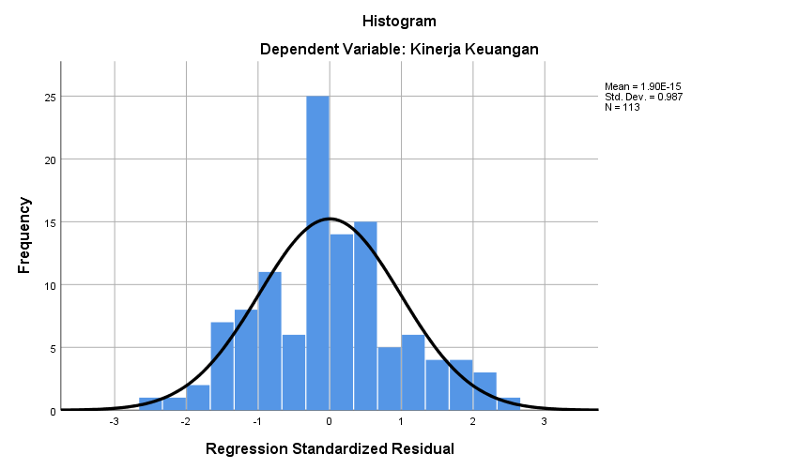

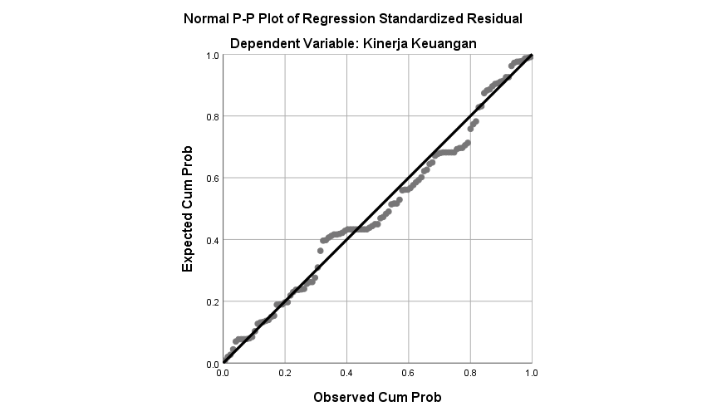

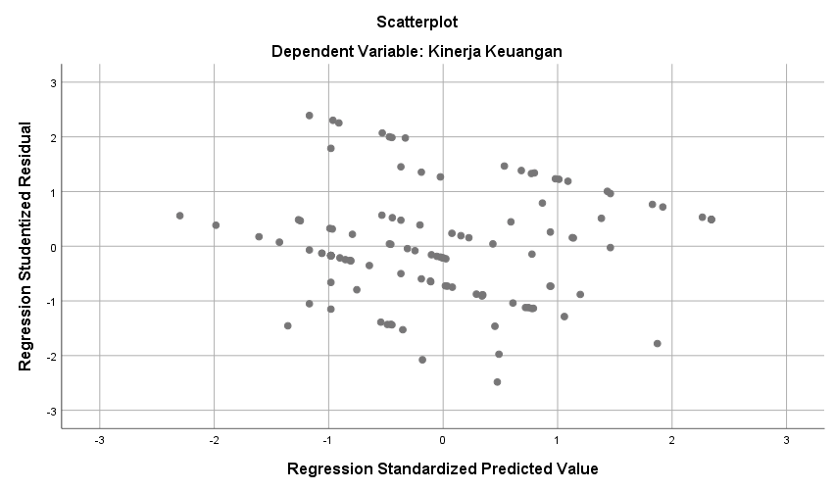

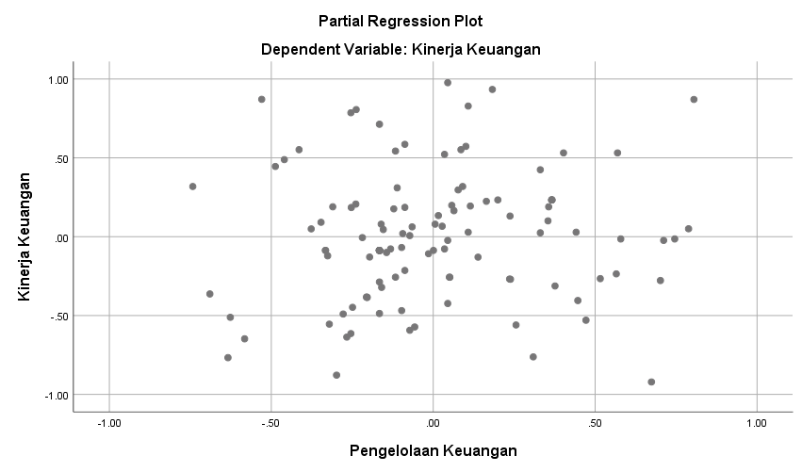

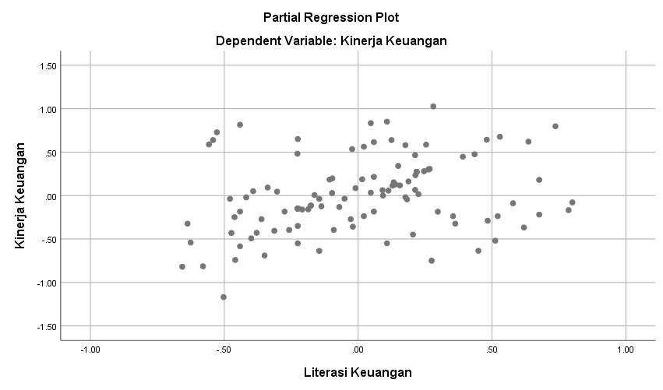

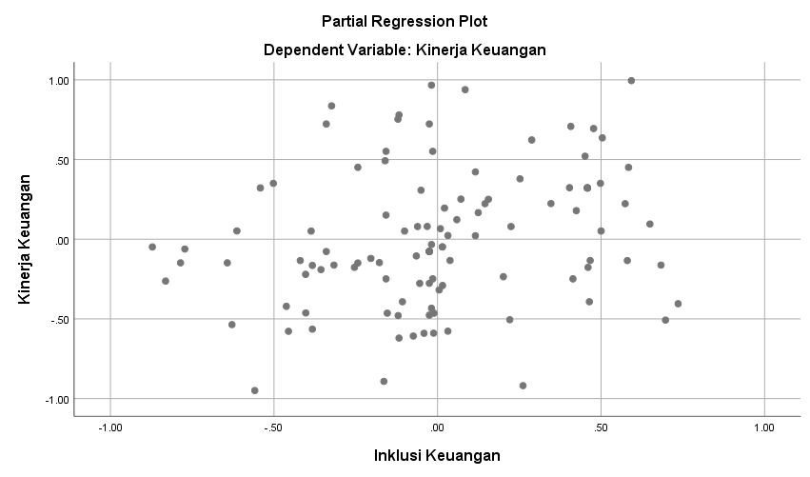

NPar Tests

One-Sample Kolmogorov-Smirnov Test
 |  | Unstandardized Residual
N |  | 113
Normal Parameters^{a,b} | Mean | ,0000000
Normal Parameters^{a,b} | Std, Deviation | ,40650710
Most Extreme Differences | Absolute | ,081
Most Extreme Differences | Positive | ,081
Most Extreme Differences | Negative | -,076
Test Statistic |  | ,081
Asymp, Sig, (2-tailed) |  | ,067^{c}
a, Test distribution is Normal,
b, Calculated from data,
c, Lilliefors Significance Correction,

Regression

Variables Entered/Removedª
Model | Variables Entered | Variables Removed | Method
1 | Inklusi Keuangan, Pengelolaan Keuangan, Literasi Keuangan^{b} | , | Enter
a, Dependent Variable: ABS_URES
b, All requested variables entered,

Model Summary
Model | R | R Square | Adjusted R Square | Std, Error of the Estimate
1 | ,118ª | ,014 | -,013 | ,25773
a, Predictors: (Constant), Inklusi Keuangan, Pengelolaan Keuangan, Literasi Keuangan

ANOVAª
Model |  | Sum of Squares | df | Mean Square | F | Sig,
1 | Regression | ,102 | 3 | ,034 | ,512 | ,675^{b}
1 | Residual | 7,240 | 109 | ,066
1 | Total | 7,342 | 112
a, Dependent Variable: ABS_URES
b, Predictors: (Constant), Inklusi Keuangan, Pengelolaan Keuangan, Literasi Keuangan

Coefficientsª
Model |  | Unstandardized Coefficients |  | Standardized Coefficients | t | Sig,
 |  | B | Std, Error | Beta | t | Sig,
1 | (Constant) | ,174 | ,283 |  | ,615 | ,540
1 | Pengelolaan Keuangan | -,053 | ,074 | -,075 | -,713 | ,477
1 | Literasi Keuangan | ,031 | ,070 | ,047 | ,443 | ,658
1 | Inklusi Keuangan | ,066 | ,068 | ,101 | ,965 | ,337
a, Dependent Variable: ABS_URES

