UNDERSTANDING THE INFLUENCE OF CORPORATE SOCIAL RESPONSIBILITY AND BRAND IMAGE ON CUSTOMER LOYALTY, USING CUSTOMER SATISFACTION AS AN INTERMEDIARY FACTOR

Alfira Agustina Indriawati*
¹Department of Management, Faculty of Economic and Business, Siliwangi University
firraagustine2003@gmail.com

Table 1. Operational Definition Of Variables
Variable | Item Measurement | Reference
CSR  (X1) | - Maximize company profits.  - Contribute to economic growth  - Comply with applicable laws and regulations.  - Be accountable to ethical standards.  - Caring for the community.  - Caring for the environment | Carroll, A. B. (2016)
Brand Image  (X2) | - The brand must be memorable  - Brands must be able to increase  consumer confidence and create  a good brand image  - Brand as an identity to differentiate  - itself from competitors.  - Brands must have uniqueness  - Good products and services | Tjiptono (2020)
Customer Satisfaction  (X3) | - The product must be able to  influence consumer perception  - Products must be consistent and reliable.  - Fast and efficient service.  - Care for consumers  - Products must provide assurance  of trust and confidence to customers. | Tjiptono (2020)
Customer Loyalty  (Y) | - Consumers' choice to repurchase the goods  - their recommendation of the product  - the diminishing impact of rival products  - their brand loyalty  - their sentiments or emotional assessments of the brand | Tjiptono (dalam Mashuri., 2020)

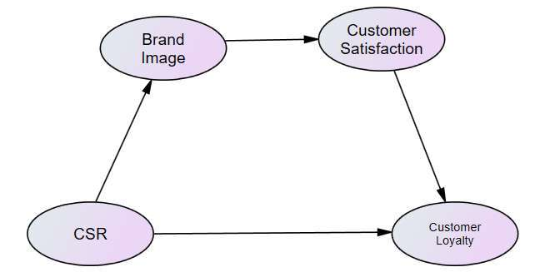
Figure 1. Conceptual Model of Research

TABLE 2. VALIDITY & RELIABILITY TEST RESULTS
Variable | Item | Factor  Loading | Construct Reliability | Average  Variance  Extracted
CSR | C1 | 0,772 | 0,877 | 0,544
CSR | C2 | 0,787 | 0,877 | 0,544
CSR | C3 | 0,727 | 0,877 | 0,544
CSR | C4 | 0,727 | 0,877 | 0,544
CSR | C5 | 0,736 | 0,877 | 0,544
CSR | C6 | 0,774 | 0,877 | 0,544
Brand Image | B1 | 0,773 | 0,889 | 0,616
Brand Image | B2 | 0,778 | 0,889 | 0,616
Brand Image | B3 | 0,848 | 0,889 | 0,616
Brand Image | B4 | 0,792 | 0,889 | 0,616
Brand Image | B5 | 0,793 | 0,889 | 0,616
Customer Satisfaction | CS1 | 0,823 | 0,884 | 0,604
Customer Satisfaction | CS2 | 0,771 | 0,884 | 0,604
Customer Satisfaction | CS3 | 0,748 | 0,884 | 0,604
Customer Satisfaction | CS4 | 0,755 | 0,884 | 0,604
Customer Satisfaction | CS5 | 0,831 | 0,884 | 0,604
Customer Loyalty | CL1 | 0,807 | 0,900 | 0,644
Customer Loyalty | CL2 | 0,801 | 0,900 | 0,644
Customer Loyalty | CL3 | 0,859 | 0,900 | 0,644
Customer Loyalty | CL4 | 0,771 | 0,900 | 0,644
Customer Loyalty | CL5 | 0,771 | 0,900 | 0,644

Table 3. Assessment Of Goodness Of Fit Analysis Results
Goodness of fit index | Cut-off value | Research model | Model
Chi Square | As small as possible | 225,201
Probability | ≥ 0,5 | 0,023 | Not fit
CMIN/DF | ≤ 2.00 | 1,217 | Good fit
RMSEA | ≤ 0,08 | 0,038 | Good fit
GFI | ≥ 0,90 | 0,879 | Marginal fit
AGFI | ≥ 0,90 | 0,849 | Marginal fit
TLI | ≥ 0,95 | 0,978 | Good fit
CFI | ≥ 0,95 | 0,981 | Good fit

Table 4. Relationship Between Variables
→ |  | Estimate | S.E. | C.R. | P | Hypothesis
CSR | BI | 0,812 | 0,101 | 8,032 | 0,000 | Significant positive
BI | CS | 0,869 | 0,092 | 9,411 | 0,000 | Significant positive
CS | CL | 0,348 | 0,091 | 3,821 | 0,000 | Significant positive
CSR | CL | 0,541 | 0,103 | 5,236 | 0,000 | Significant positive

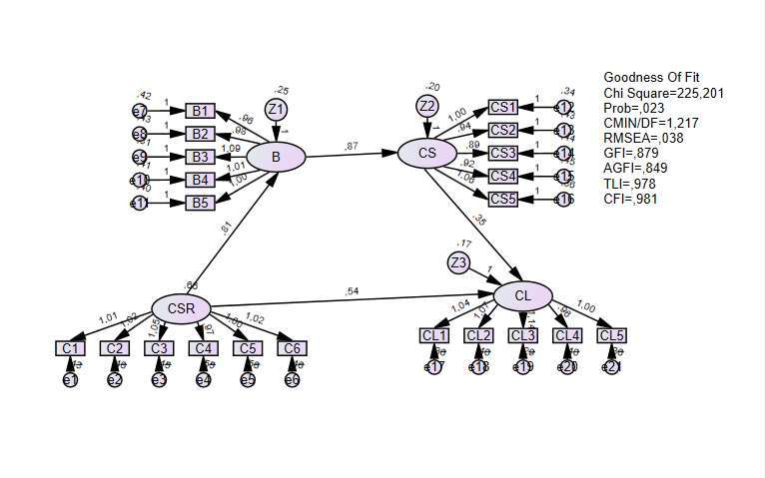
Figure 2. Research Model Test Results

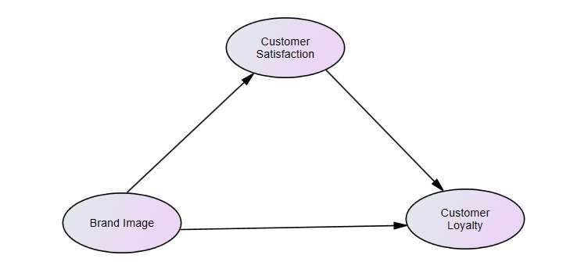
Figure 3. Research Mediation Model

Table 5. The Effect Of Mediating Variables
 | B | CS | CL
CS | 0 | 0 | 0
CL | 0,315 | 0 | 0

Table 6. Significance Of Mediating Variables
 | B | CS | CL
CS | .. | ... | ...
CL | 0,006 | ... | ...

