Figure 1. Conceptual Framework
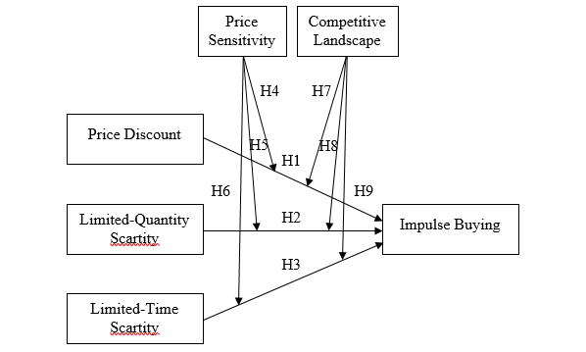
Table 1. Construct Validity
Variable | Indicator | Loading Factor | Information
Price Discount | PD1 | 0,874 | Valid
Price Discount | PD2 | 0,873 | Valid
Price Discount | PD3 | 0,854 | Valid
Price Discount | PD4 | 0,881 | Valid
Price Discount | PD5 | 0,881 | Valid
Price Discount | PD6 | 0,868 | Valid
Price Discount | PD7 | 0,833 | Valid
Price Discount | PD8 | 0,862 | Valid
Price Discount | PD9 | 0,868 | Valid
Limited-Quantity Scarcity | LQS1 | 0,88 | Valid
Limited-Quantity Scarcity | LQS2 | 0,865 | Valid
Limited-Quantity Scarcity | LQS3 | 0,872 | Valid
Limited-Time Scarcity | LTS1 | 0,871 | Valid
Limited-Time Scarcity | LTS2 | 0,849 | Valid
Limited-Time Scarcity | LTS3 | 0,868 | Valid
Price Sensitivity | PS1 | 0,848 | Valid
Price Sensitivity | PS2 | 0,871 | Valid
Price Sensitivity | PS3 | 0,834 | Valid
Price Sensitivity | PS4 | 0,824 | Valid
Price Sensitivity | PS5 | 0,868 | Valid
Price Sensitivity | PS6 | 0,835 | Valid
Competitive Landscape | CL1 | 0,994 | Valid
Competitive Landscape | CL2 | 0,991 | Valid
Competitive Landscape | CL3 | 0,579 | Valid
Impulse Buying | IB1 | 0,647 | Valid
Impulse Buying | IB2 | 0,845 | Valid
Impulse Buying | IB3 | 0,845 | Valid
Impulse Buying | IB4 | 0,854 | Valid
Impulse Buying | IB5 | 0,843 | Valid
Impulse Buying | IB6 | 0,838 | Valid
Impulse Buying | IB7 | 0,843 | Valid

Table 2. Average Variance Extracted (AVE)
Variable | AVE | Information
Price Discount | 0,75 | Valid
Limited-Quantity Scarcity | 0,761 | Valid
Limited-Time Scarcity | 0,744 | Valid
Price Sensitivity | 0,717 | Valid
Competitive Landscape | 0,768 | Valid
Impulse Buying | 0,671 | Valid

Table 3. Construct Reliability
Variable | AVE | Information
Price Discount | 0,964 | Reliable
Limited-Quantity Scarcity | 0,905 | Reliable
Limited-Time Scarcity | 0,897 | Reliable
Price Sensitivity | 0,938 | Reliable
Competitive Landscape | 0,904 | Reliable
Impulse Buying | 0,934 | Reliable

Table 4. Goodness of Fit
Index | Value Cutoff | Result | Information
Chi-Square | As small as possible | 1,025.87 | Poor Fit
Probability | ≥ 0.05 | 0.000 | Poor Fit
CMIN/DF | ≤ 2.00 | 1.803 | Good Fit
RMSEA | ≤ 0.08 | 0.062 | Good Fit
GFI | ≥ 0.90 | 0.798 | Poor Fit
AGFI | ≥ 0.90 | 0.750 | Poor Fit
TLI | ≥ 0.95 | 0.950 | Good Fit
CFI | ≥ 0.95 | 0.957 | Good Fit

Table 5. Regression Weights
Hypothesis | Path | β | p-value
H1 | PD IB | -1.53 | 0.701
H2 | LQS IB | 1.702 | 0.571
H3 | LTS IB | -0.019 | 0.993

Table 6. Regression Weights
Hypothesis | Path | β | p-value
H4 | PD*PS IB | 0.604 | 0.72
H5 | LQS*PS IB | -1.322 | 0.556
H6 | LTS*PS IB | 0.058 | 0.938
H7 | PD*CL IB | 1.804 | 0.759
H8 | LQS*CL IB | -0.237 | 0.896
H9 | LTS*CL IB | -0.524 | 0.713

