HASIL OLAH DATA SPSS 2025

- REABILITAS

- Gaya Kepemimpinan (X1)
Reliability Statistics
Cronbach's Alpha | N of Items
,603 | 4

- Motivasi Kerja (X2)
Reliability Statistics
Cronbach's Alpha | N of Items
,636 | 5

- Kondisi Kerja (X3)
Reliability Statistics
Cronbach's Alpha | N of Items
,727 | 6

- Kinerja Pegawai (Y)
Reliability Statistics
Cronbach's Alpha | N of Items
,827 | 10

- VALIDITAS
- Gaya kepemimpinan (X1)
Item-Total Statistics
 | Scale Mean if Item Deleted | Scale Variance if Item Deleted | Corrected Item-Total Correlation | Cronbach's Alpha if Item Deleted
GP01 | 13,37 | 1,737 | ,360 | ,551
GP05 | 13,56 | 1,393 | ,521 | ,417
GP06 | 13,39 | 1,598 | ,378 | ,537
GP07 | 13,47 | 1,718 | ,288 | ,604

- Motivasi Kerja (X2)
Item-Total Statistics
 | Scale Mean if Item Deleted | Scale Variance if Item Deleted | Corrected Item-Total Correlation | Cronbach's Alpha if Item Deleted
MO02 | 18,35 | 3,125 | ,291 | ,628
MO03 | 18,30 | 2,963 | ,458 | ,554
MO04 | 18,21 | 2,919 | ,471 | ,547
MO05 | 18,18 | 3,147 | ,447 | ,568
MO06 | 18,54 | 2,395 | ,370 | ,621

- Kondisi Kerja ( X3)
Item-Total Statistics
 | Scale Mean if Item Deleted | Scale Variance if Item Deleted | Corrected Item-Total Correlation | Cronbach's Alpha if Item Deleted
KK01 | 22,93 | 3,531 | ,496 | ,680
KK02 | 22,98 | 3,339 | ,543 | ,664
KK03 | 22,86 | 3,801 | ,419 | ,702
KK04 | 22,95 | 3,729 | ,308 | ,735
KK06 | 22,96 | 3,570 | ,421 | ,701
KK07 | 23,04 | 3,070 | ,598 | ,643

- Kinerja Pegawai ( Y)
Item-Total Statistics
 | Scale Mean if Item Deleted | Scale Variance if Item Deleted | Corrected Item-Total Correlation | Cronbach's Alpha if Item Deleted
KP01 | 41,40 | 11,138 | ,569 | ,806
KP02 | 41,32 | 11,077 | ,554 | ,807
KP03 | 41,18 | 12,397 | ,322 | ,828
KP04 | 41,26 | 11,697 | ,465 | ,816
KP05 | 41,26 | 10,769 | ,614 | ,801
KP06 | 41,30 | 11,070 | ,559 | ,807
KP07 | 41,39 | 10,634 | ,566 | ,806
KP08 | 41,25 | 11,653 | ,531 | ,811
KP09 | 41,40 | 10,816 | ,449 | ,823
KP10 | 41,30 | 11,284 | ,537 | ,809

- Regression

Model Summary^{b}
Model | R | R Square | Adjusted R Square | Std. Error of the Estimate | Durbin-Watson
1 | ,849ª | ,721 | ,705 | ,20038 | 2,021
a. Predictors: (Constant), Kondisi Kerja, Gaya Kepemimpinan, Motivasi Kerja
b. Dependent Variable: Kinerja Pegawai

ANOVAª
Model |  | Sum of Squares | df | Mean Square | F | Sig.
1 | Regression | 5,506 | 3 | 1,835 | 45,707 | ,000^{b}
1 | Residual | 2,128 | 53 | ,040
1 | Total | 7,634 | 56
a. Dependent Variable: Kinerja Pegawai
b. Predictors: (Constant), Kondisi Kerja, Gaya Kepemimpinan, Motivasi Kerja

Coefficientsª
Model |  | Unstandardized Coefficients |  | Standardized Coefficients | t | Sig. | Correlations |  |  | Collinearity Statistics
 |  | B | Std. Error | Beta | t | Sig. | Zero-order | Partial | Part | Tolerance | VIF
1 | (Constant) | ,620 | ,454 |  | 1,365 | ,178
1 | Gaya Kepemimpinan | -,157 | ,118 | -,123 | -1,328 | ,190 | ,438 | -,180 | -,096 | ,613 | 1,630
1 | Motivasi Kerja | ,745 | ,106 | ,736 | 7,027 | ,000 | ,831 | ,694 | ,510 | ,480 | 2,085
1 | Kondisi Kerja | ,275 | ,117 | ,243 | 2,340 | ,023 | ,676 | ,306 | ,170 | ,490 | 2,042
a. Dependent Variable: Kinerja Pegawai

Collinearity Diagnosticsª
Model | Dimension | Eigenvalue | Condition Index | Variance Proportions
 |  |  |  | (Constant) | Gaya Kepemimpinan | Motivasi Kerja | Kondisi Kerja
1 | 1 | 3,993 | 1,000 | ,00 | ,00 | ,00 | ,00
1 | 2 | ,003 | 34,972 | ,54 | ,02 | ,35 | ,05
1 | 3 | ,002 | 46,709 | ,27 | ,91 | ,00 | ,24
1 | 4 | ,002 | 48,900 | ,20 | ,06 | ,65 | ,71
a. Dependent Variable: Kinerja Pegawai

Residuals Statisticsª
 | Minimum | Maximum | Mean | Std. Deviation | N
Predicted Value | 3,8250 | 4,9804 | 4,5895 | ,31355 | 57
Std. Predicted Value | -2,438 | 1,247 | ,000 | 1,000 | 57
Standard Error of Predicted Value | ,032 | ,107 | ,051 | ,015 | 57
Adjusted Predicted Value | 3,8509 | 4,9794 | 4,5876 | ,31494 | 57
Residual | -,65899 | ,36170 | ,00000 | ,19494 | 57
Std. Residual | -3,289 | 1,805 | ,000 | ,973 | 57
Stud. Residual | -3,331 | 1,961 | ,005 | 1,003 | 57
Deleted Residual | -,67600 | ,42705 | ,00191 | ,20747 | 57
Stud. Deleted Residual | -3,710 | 2,017 | -,004 | 1,036 | 57
Mahal. Distance | ,426 | 14,982 | 2,947 | 2,622 | 57
Cook's Distance | ,000 | ,174 | ,016 | ,028 | 57
Centered Leverage Value | ,008 | ,268 | ,053 | ,047 | 57
a. Dependent Variable: Kinerja Pegawai

Charts

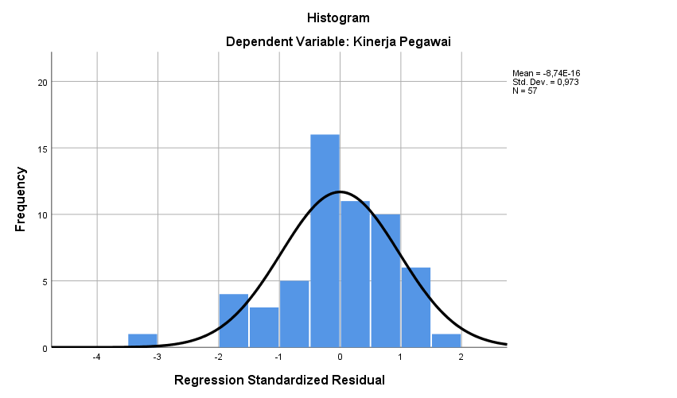

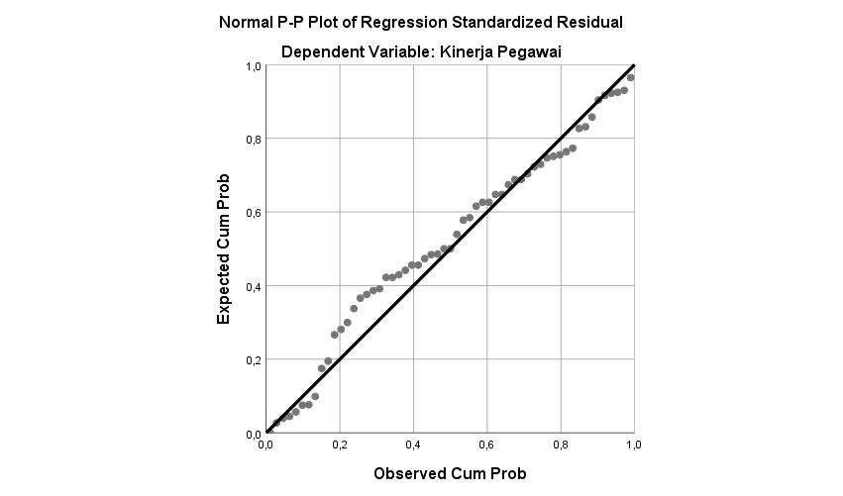

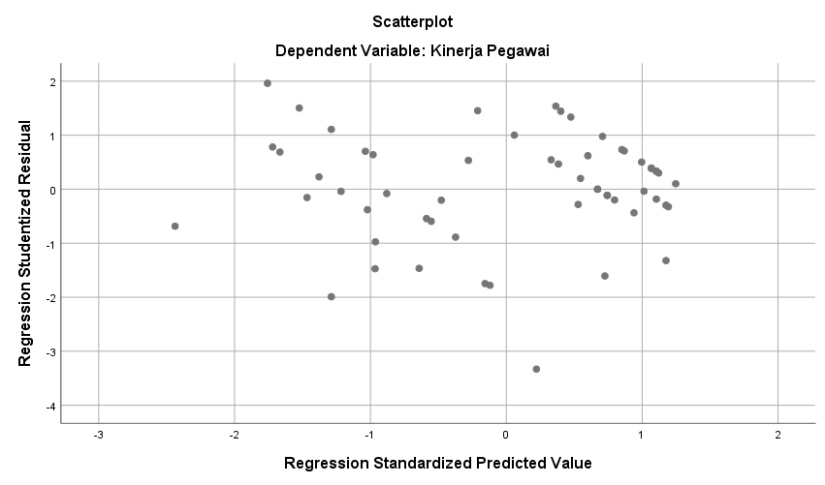

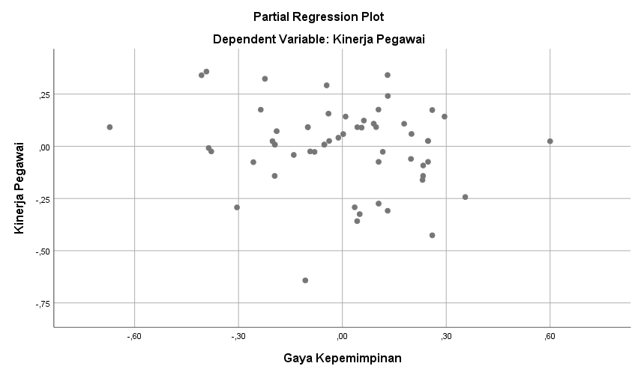

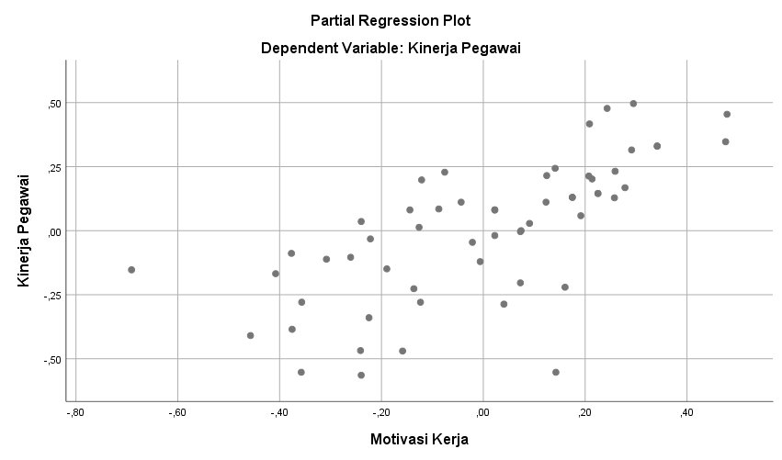

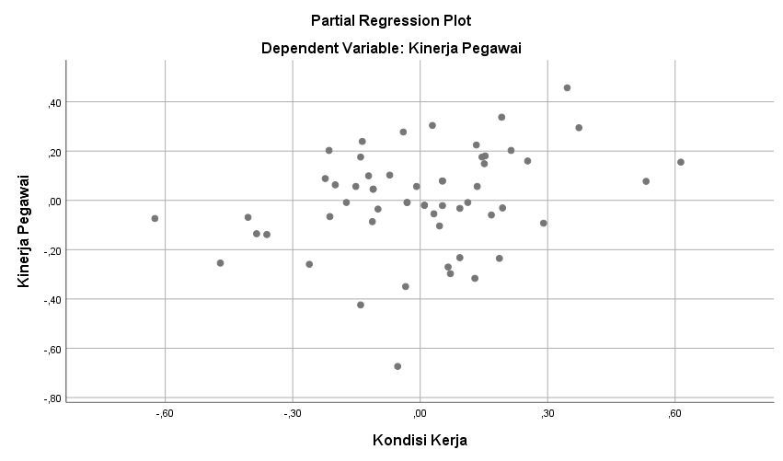

NPar Tests

One-Sample Kolmogorov-Smirnov Test
 |  | Unstandardized Residual
N |  | 57
Normal Parameters^{a,b} | Mean | ,0000000
Normal Parameters^{a,b} | Std. Deviation | ,19493762
Most Extreme Differences | Absolute | ,116
Most Extreme Differences | Positive | ,063
Most Extreme Differences | Negative | -,116
Test Statistic |  | ,116
Asymp. Sig. (2-tailed) |  | ,052^{c}
a. Test distribution is Normal.
b. Calculated from data.
c. Lilliefors Significance Correction.

